Chapter 7, Solution 75.

In the circuit of Fig. 7.140, find v_{o} and i_{o}, given that v_{s} = 4 u(t) V and v(0) = 1 V.
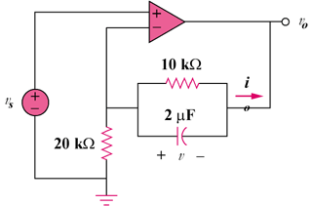

Figure 7.140
For Prob. 7.75.

Solution

Let = voltage at the noninverting terminal.
Let = voltage at the inverting terminal.

For t > 0,
,
(1)

Also, , ,
i.e. (2)

This is a step response.
,
where

At steady state, the capacitor acts like an open circuit so that passes through . Hence, as
i.e.

But
or
= [6 – 3e^{–50t}]

or

